Thru gate (or a Hole gate) Dive gate Ladder gate (Just like hole gate but with more (layers’) The Thru / Hole gate: The drone simply flies thru the holes. The Dive gate: The drone either comes up thru the bottom or goes down thru the top. Now when racing the drone would pass thru such in a sweeping motion but with our demo I would expect the drone flight path to be more ‘rigged’. Fly to center of gate hole – either above or below the hole – and then go either up or down thru the hole. And then fly off in whatever direction after that. Ladder gate… Again, the drone simply flies thru the holes. But with the ladder gate… Like in our ‘classroom’ settings… We challenge the pilots to fly thru each hole. So say starting at the bottom… Fly thru the bottom hole - then turn around (yaw 180) – t­­­hen throttle UP (go up) – Then pitch fwd thru the next hole. Then yaw 180 again. Then go up again. Then fly thru next (upper) hole. Understand? (Obviously you can decide first go up or down then yaw to face the hole – OR yaw first then go up or down. COULD also simply ‘back thru’ the gate hole – not yawing, turning around at all.  
An alternative to the YAW approach would be to have the plot use ROLL (and / or yaw actually) to circle around the gate and thru the holes. Again a more ‘fluid, sweeping flight but same idea… Progressing thru the holes in either an upward or downward path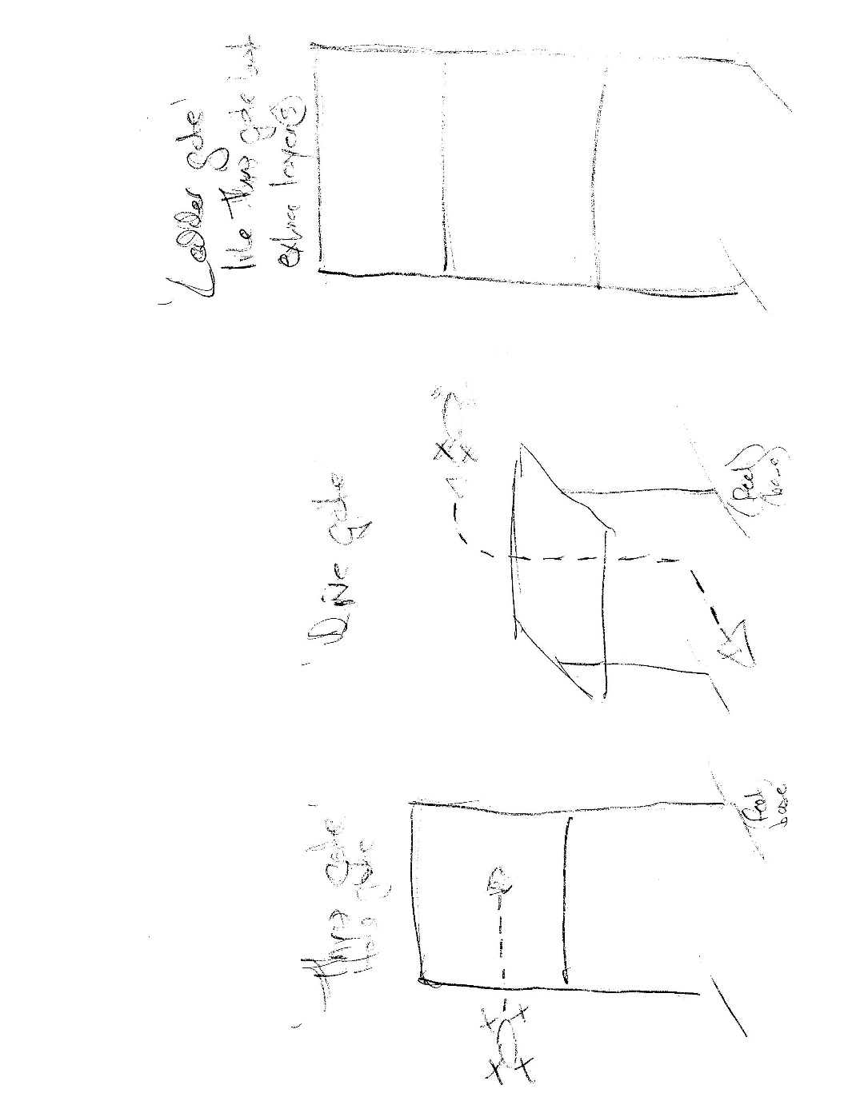.

ANY flight path thru these gate holes is fine by me!!! So I can make these gates pretty much any size to fit any flight plan you might put together but USUALLY they are of the following dimensions 30” ‘legs’ (Approx. 76cm) That being…, The first bar going across on the Hole gate is approx.. 30” high. (Again, approx 76cm up) And so on the Ladder gate there would be a bar going across every 30”. And those bars going across… They are 30”. So it’s a 30”x30” hole. The Dive gate stands on 30” legs so it sits, obviously, about 30” high. It too is a 30x30 hole. So these are pretty big holes for the small Tello to go thru.  
Happy and free to talk directly now if you’d like. THANK YOU!!!!